**Jacobs University Bremen**

**CO-520-B: Signals and Systems Lab**

**Fall 2021**

**Lab Experiment 5: AM Modulation**

**Priontu Chowdhury**

**Introduction**

**Objective**

The objective of this lab was to study different analog modulation techniques. We have primarily focused on amplitude modulation. We examined properties of double-sideband modulation, double-sideband suppressed carrier modulation and single-sideband amplitude modulation. Techniques for demodulation were also part of the experiment.

We used the oscilloscope to demonstrate the impact of amplitude modulation parameters on the modulated signal in the frequency and time domain. Furthermore, we built a complete amplitude modulation-based system using the function generator as a modulator and the envelope detector as the demodulator.

One reason modulation is important is because attenuation of the channel is high for low frequency signals, while it is significantly lower for high frequency signals. Laws of electromagnetic propagation also make modulation quite important: the size of the radiating element, the antenna, is required to be a significant fraction of the wavelength of the signal being transmitted. Therefore, if we want to use smaller antenna, we need to modulate the signal.

**Theory**

**Band-limited signal AM modulation**

A sinusoidal carrier signal has the following mathematical form:



For convenience, is suppressed and we end up with the following carrier:



The modulating signal could be music, video or any other bandlimited signal. The amplitude of the carrier wave is varied about a mean value, linearly with the modulating signal. As a result, the envelope of the modulated signal has the same shape as the modulating signal.

Mathematically, we can demonstrate this as follows:

, where k is the transmitter sensitivity

Proper modulation has the following requirements:

1. The amplitude of (kx(t)) is always less than unity, that is, |km(t)| < 1 for all t. Otherwise the carrier wave becomes overmodulated and the modulated signal then exhibits envelope distortion.
2. The carrier signal fc must be greater than the highest frequency component W of the message signal x(t), or else the envelope cannot be visualized.

**Single frequency AM modulation**

Let, x(t) contains a single frequency component:



The carrier signal modulated by the band-limited modulating signal can be demonstrated as follows:



where m = kAm,

and m is called the modulating index/factor. To avoid overmodulation ‘m’ must be kept below unity.

**Prelab: AM Modulation**

**Problem 1: Single frequency Amplitude Modulation**

**Question 1**

We know that,

The modulation index is the ratio of modulating signal amplitude to carrier signal amplitude, which provides us with the following:

**Question 2**

Carrier power, side-band power and total power are given as follows:

**Question 3**

Modulation index is 100%, therefore,

**Question 4**

In this case, due to presence of an offset, we need to formulate as follows:

The DC offset contributes to the total power. In order to maximize the ratio, the DC offset needs to be reduced.

**Problem 2: Amplitude Demodulation**

For this task, we use MATLAB to simulate the demodulation of an AM signal. We have a sinusoidal carrier signal with frequency 20kHz and amplitude of 5V. The sinusoidal modulation signal has a frequency of 500Hz and a modulation index of 50%.

Note:

The MATLAB script for the whole section will be provided together at the end of the section, as part of the last question. The script will be categorized based on the task.

**Question 1**

We are required to generate the modulated signal in time and frequency domain. In order to establish this, we first build the modulating and carrier signals. These are provided below:

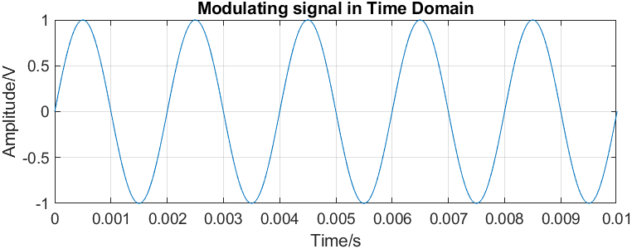

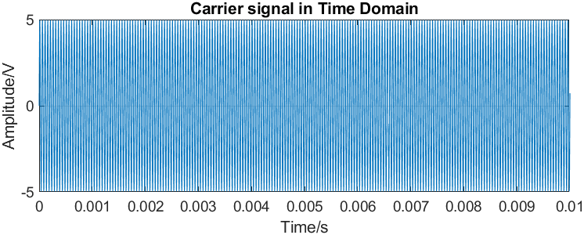

The modulated signal and its spectrum are provided below:

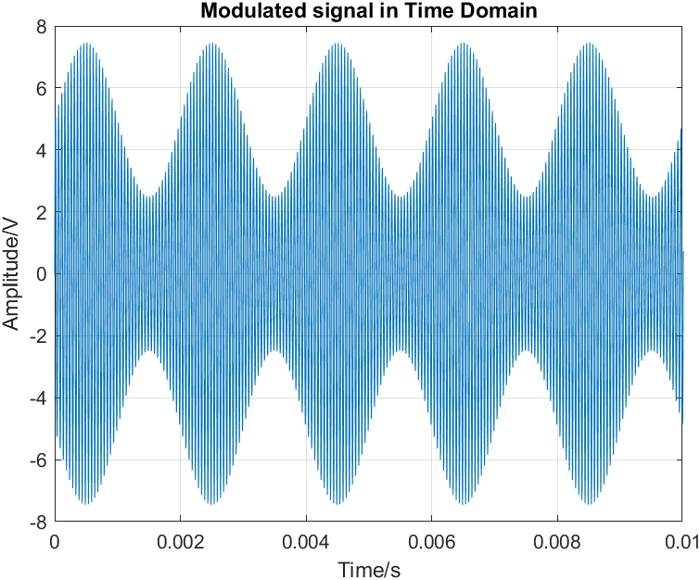

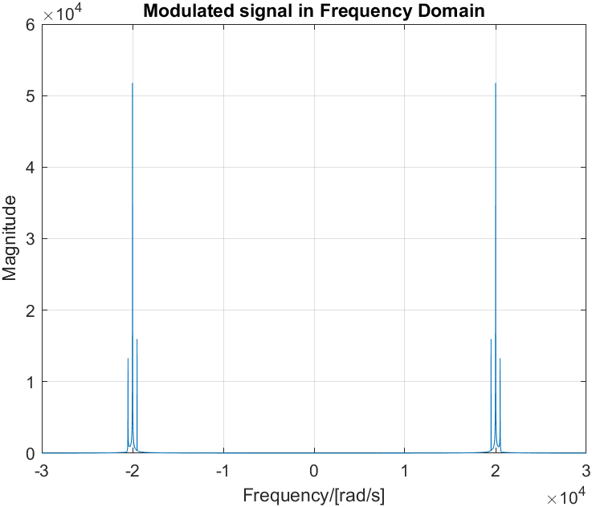

**Question 2**

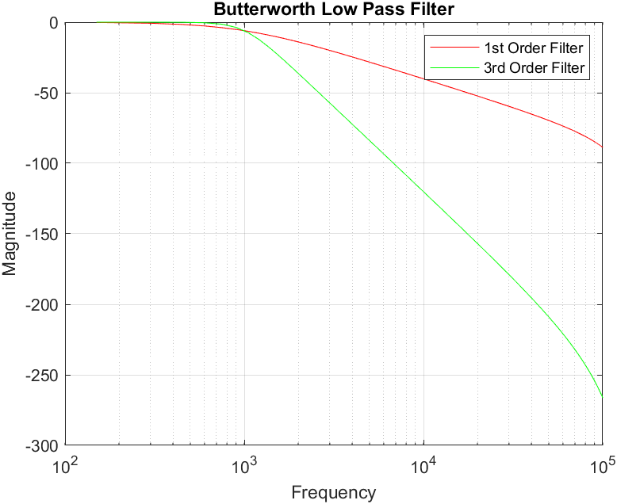

**Question 3**

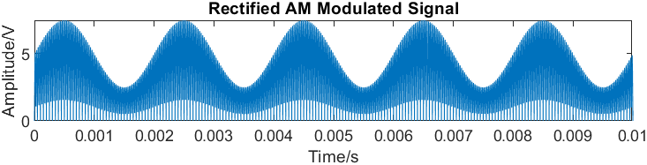

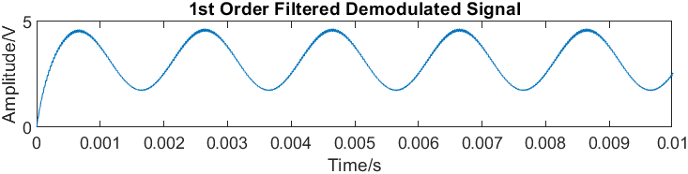

**Question 4**

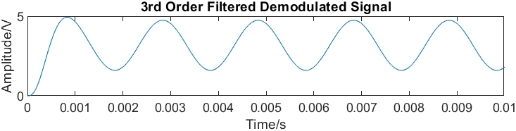

**Question 5**

From the above plots, we can see that the plot for the demodulated signal filtered with the 3rd order filter is much smoother and sharper than the plot of the one filtered with the 1st order filter. This means that some residual effects of the carrier signal have carried onto the 1st order filtered demodulated signal. Even if the same has occurred with the 3rd order filtered demodulated signal, relatively the effects seem to be very much lower. Therefore, we can conclude that the higher the order of the filter, the lower the distortion carried over from the carrier.

**Question 6**

The overall MATLAB script for all the tasks above is provided below:

%% Question 1

%Signal properties:

m = 0.5; %modulation index

N = 25000; %number of samples

Fs = 300000; %sampling frequency

Fc = 20000; %carrier signal frequency

Fm = 500; %modulating signal frequency

Ts = 1/Fs; %sampling period

%Setting up time and frequency domains:

t_dom = 0: Ts: ((N*Ts)-Ts); %time domain built using Ts

f_dom = -Fs/2: Fs/N: Fs/2 - Fs/N; %frequency domain build using Fs

%Radian frequencies:

w_c = 2*pi*Fc; %carrier radian frequency

w_x = 2*pi*Fm; %modulating radian frequency

%Generating carrier and modulating signal:

c = 5*sin(w_c*t_dom); %carrier signal

x = sin(w_x*t_dom); %modulation signal

%Generating modulated signal:

y = (1+m*x).*c; %modulated signal

%Generating FFT of modulated signal:

Y = fft(y); %FFT Spectrum

%Plotting modulating and carrier signals:

figure(1)

subplot(2,1,1);

plot(t_dom, x);

title('Modulating signal in Time Domain');

xlabel('Time/s');

ylabel('Amplitude/V');

xlim([0,0.01]);

grid on;

subplot(2,1,2);

plot(t_dom, c);

title('Carrier signal in Time Domain');

xlim([0,0.01]);

ylabel('Amplitude/V');

xlabel('Time/s');

grid on;

%Plotting modulated signal:

figure(2)

plot(t_dom,y);

xlabel('Time/s');

ylabel('Amplitude/V');

title('Modulated signal in Time Domain');

xlim([0, 0.01]);

ylim([-8, 8]);

grid on;

%Plotting spectrum:

figure(3);

plot(f_dom, fftshift(abs(Y)));

ylabel('Magnitude');

xlabel('Frequency/[rad/s]');

xlim([-30000, 30000]);

title('Modulated signal in Frequency Domain');

grid on;

%% Question 2

FFc = 1000; %filter cutoff frequency

FFs = 300000; %filter sampling frequency

%1st order filter implementation:

[b1, a1]=butter(1,(FFc/(FFs/2)),'low'); %butterworth 1st order filter formulation

[h, Ff_dom]=freqz(b1, a1, 1000, FFs); %h: frequency response, f: frequency vector

H_dB = 20.*log10(h.*conj(h)); %frequency response

figure(4);

semilogx(Ff_dom, H_dB, 'r');

title('Butterworth Low Pass Filter');

xlabel('Frequency');

ylabel('Magnitude');

xlim([100,100000]); %frequency range

grid on;

hold on;

%3rd order filter implementation:

[b3,a3]=butter(3,(FFc/(FFs/2)),'low'); %butterworth 3rd order

[h,Ff_dom]=freqz(b3,a3,1000,FFs);

H_dB = 20.*log10(h.*conj(h));

semilogx(Ff_dom, H_dB, 'g');

xlim([100,100000]); %range of frequency

xlabel('Frequency');

ylabel('Magnitude');

legend('1st Order Filter','3rd Order Filter');

%References:

%https://de.mathworks.com/help/signal/ref/butter.html

%https://de.mathworks.com/help/signal/ref/freqz.html

%https://de.mathworks.com/help/matlab/ref/semilogx.html

%% Question 3

figure(5);

rec_y = abs(y);

%Rectifying the wave and plotting it:

subplot(3,1,1);

plot(t_dom, rec_y);

title('Rectified AM Modulated Signal');

xlim([0,0.01]);

xlabel('Time/s');

ylabel('Amplitude/V');

%Filtering and demodulating with 1st order filter:

y1 = filter(b1, a1, rec_y);

subplot(3,1,2);

plot(t_dom, y1);

title('1st Order Filtered Demodulated Signal');

ylabel('Amplitude/V');

xlabel('Time/s');

xlim([0, 0.01]);

%% Question 4

%Filtering and demodulating with 3rd order filter:

y3 = filter(b3, a3, rec_y);

subplot(3,1,3);

plot(t_dom, y3);

title('3rd Order Filtered Demodulated Signal');

xlabel('Time/s');

ylabel('Amplitude/V');

xlim([0,0.01]);

**Execution**

We required the following tools for this experiment:

* Agilent Signal Generator
* Tektronix Oscilloscope
* BNC-to-Kleps cable
* Breadboard
* Elabo Workbench
* Circuit components: Operational Amplifier, Diode, Capacitor, Inductor

**Problem 1: AM modulated Signals in Time Domain**

**Task 1**

To accomplish this task, we are required to generate an AM signal by the function generator. We accomplish this by generating a carrier signal and then modulating it. Consequently, the signal generator has the following settings:

Signal Shape = Sine

Modulation = AM

Carrier frequency = 20 kHz

Carrier amplitude = 10 Vpp

Modulation frequency = 500 Hz

Modulation index = 50%

With these settings, the function generator is connected to the oscilloscope. Using the oscilloscope, we measure the frequency and amplitude properties.

The following is the picture of the modulated signal:

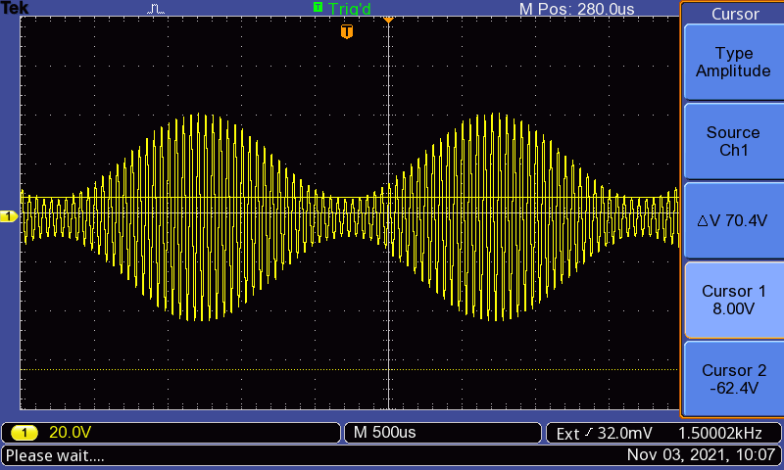

Figure: Display of modulated signal

Amplitude measurements are provided below:

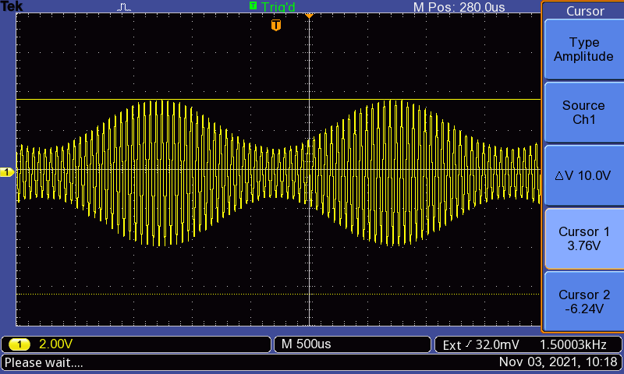

Figure: Amplitude measurements on modulated signal

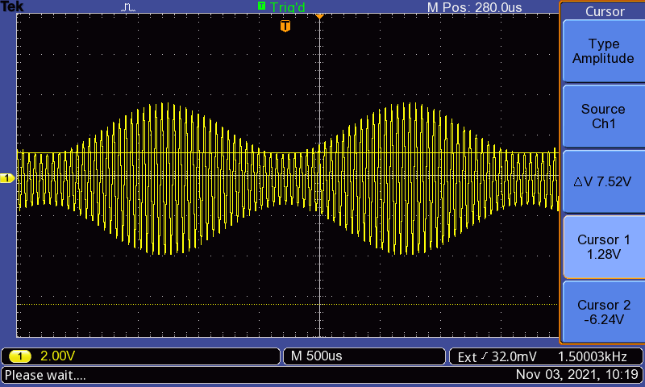

Figure: Amplitude measurements on modulated signal

Frequency measurements are provided below:

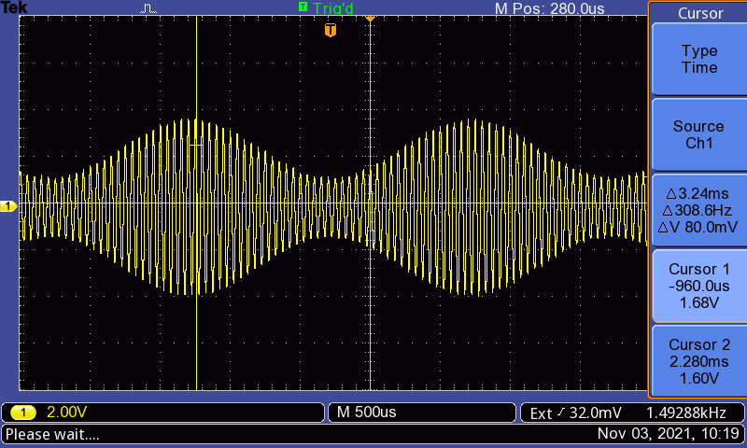

Figure: Time measurements on modulated signal

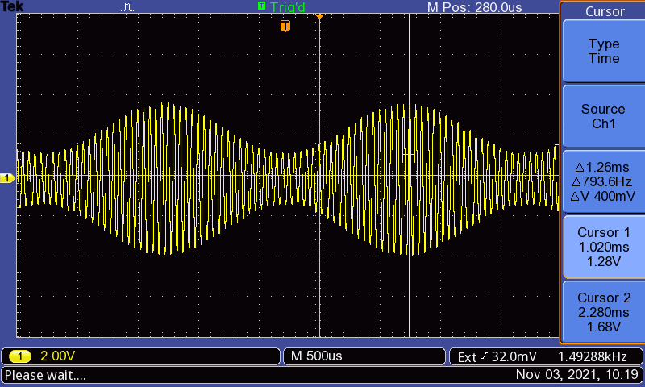

Figure: Time measurements on modulated signal

The results are the following:

Using the amplitude measurements, we can calculate the modulation index using the following:

Using the time measurements, we can find the frequency as follows:

**Task 2**

In order to complete the second task, we change the modulation index to 70%. The amplitude measurements are provided below:

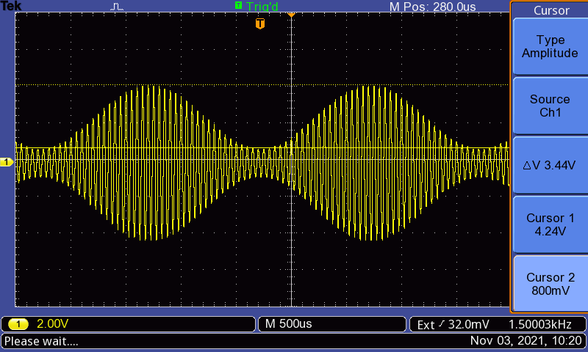

Figure: Amplitude measurements on modulated signal

Using the amplitude measurements, we can calculate the modulation index using the following:

Since we are applied amplitude modulation here, the frequency of the modulated wave did not change. Therefore, the frequency remains .

**Task 2**

For this task, we increase the modulation to 120% and take a picture of the resulting wave. The result is provided below:

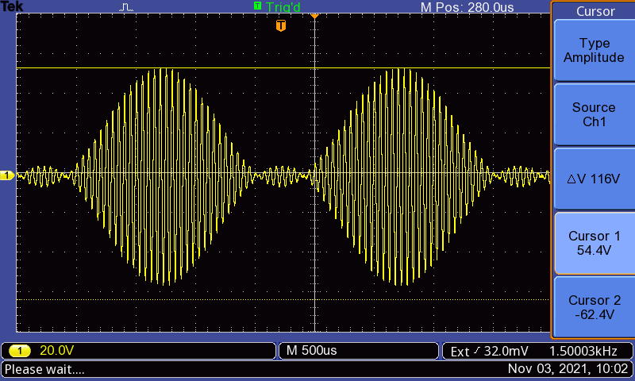

Figure: Modulation at 120% modulation index

The wave we see above is the result of overmodulation. It doesn’t make sense to take measurements on this wave since we have lost information as a result of overmodulation.

**Problem 2: AM Modulated Signals in Frequency Domain**

Using the same setup as before, we set the modulation index at the function generator to 70%. Then, we generated the FFT of the amplitude modulated signal and displaedy it on the oscilloscope. Using the cursors, we measured the magnitudes and frequencies of the peaks.

The amplitude measurements are provided below:

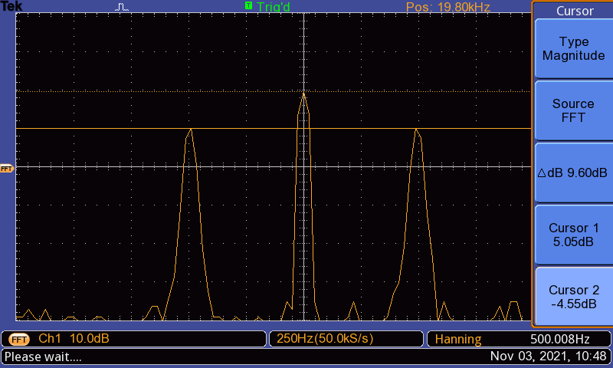

Figure: magnitude measurements for the modulated signal

Frequency measurements are provided below:

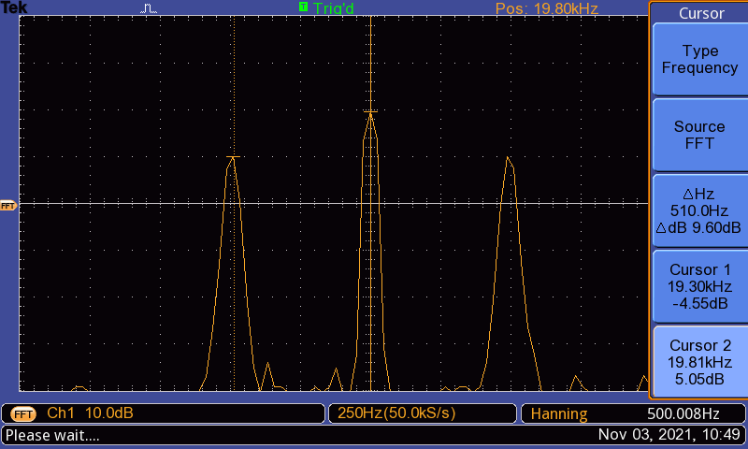

Figure: Frequency measurements of FFT

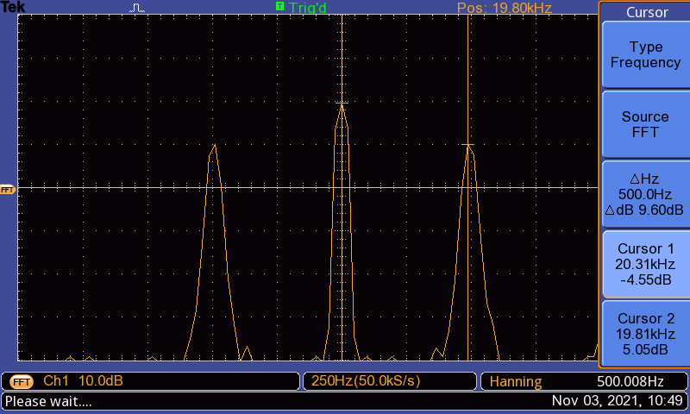

Figure: Frequency measurements of FFT

The peaks are at the following magnitudes:

Frequency measurements are provided below:

**Problem 3: Demodulation of a message signal**

To accomplish tasks for this part, we use the following setup:

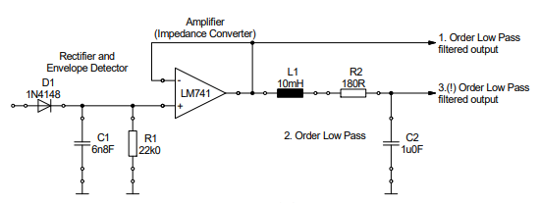

Figure: Demodulation circuit

The pinout and the necessary circuit is provided below:

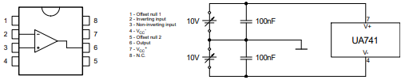

Figure: LM741 pinout and supply circuit

Practically, the complete circuit looks as follows:

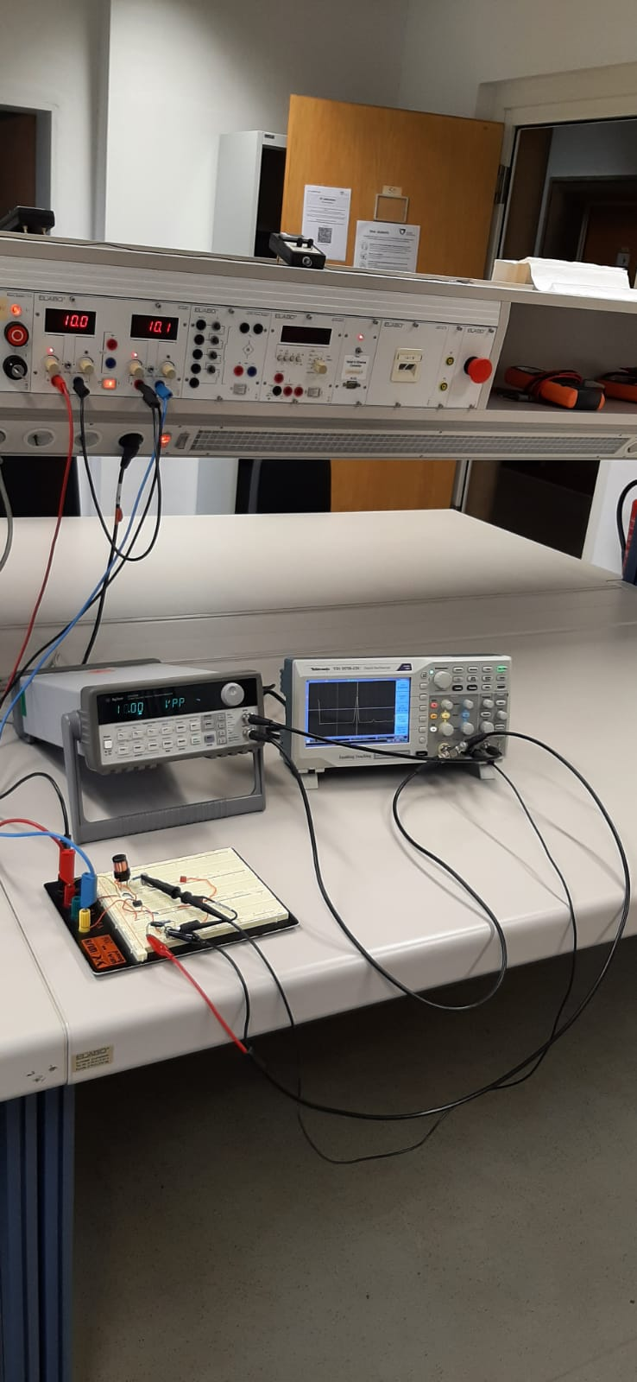 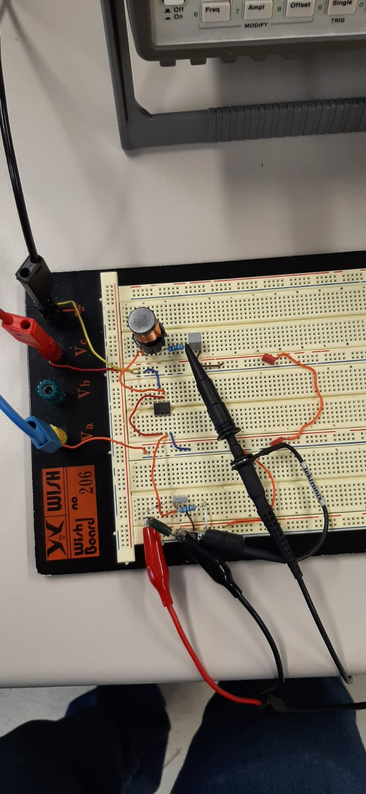

Figure: Lab setup of demodulator

The following settings were used on the signal generator:

Signal Shape = Sine

Modulation = AM

Carrier frequency = 20 KHz

Carrier Amplitude = 10 Vpp

Modulation Frequency = 500 Hz

Modulation index = 50%

**Task 1**

The AM modulated signal and the 1. Order filter output display pictures are provided below:

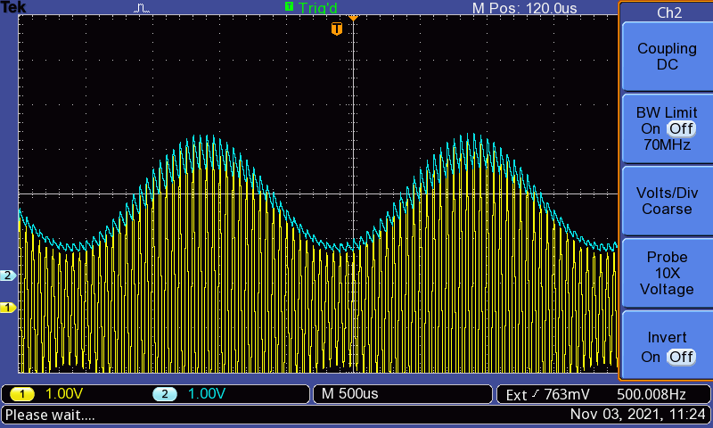

Figure: AM modulated signal and the 1. Order filter output

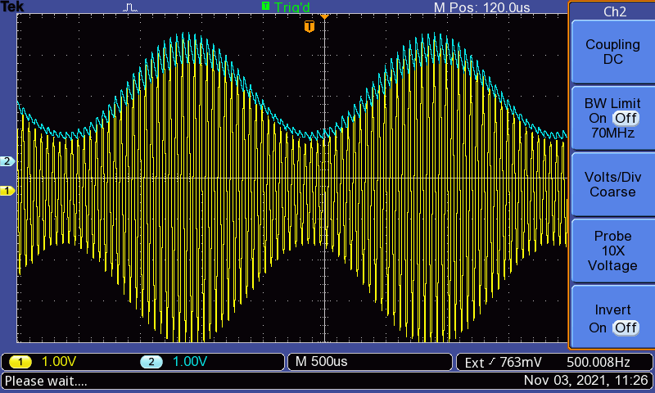

Figure: AM modulated signal and the 1. Order filter output

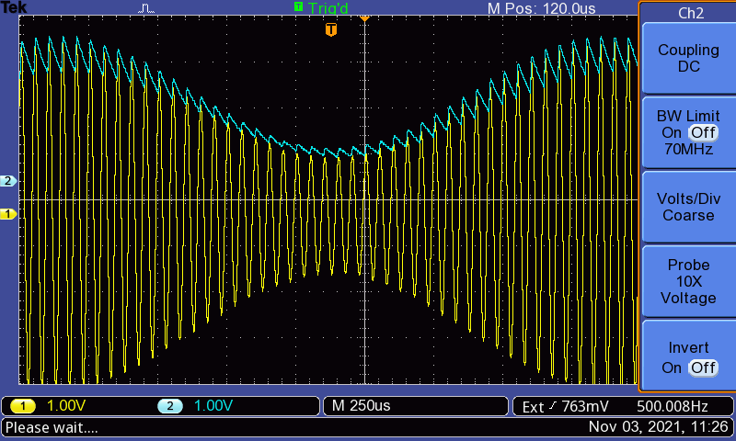

Figure: AM modulated signal and the 1. Order filter output

**Task 2**

The AM modulated signal and the 3. Order filter output pictures are provided below:

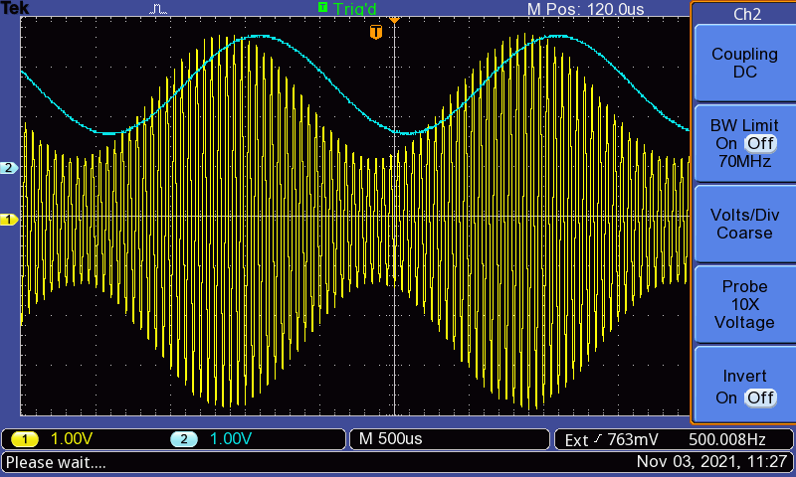

Figure: AM modulated signal and the 3. Order filter output

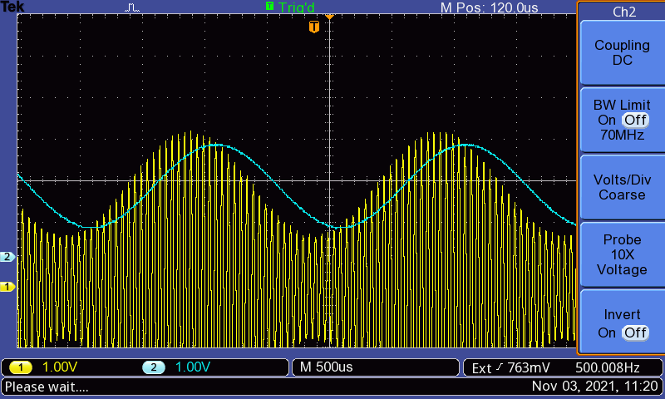

Figure: AM modulated signal and the 3. Order filter output

**Task 3**

Measurements of the amplitude of the modulated and demodulated signal is provided below:

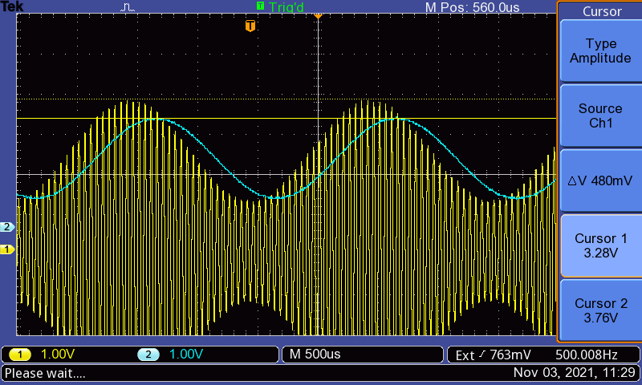

Figure: Measurements of amplitudes of modulated and demodulated signals

**Task 4**

The FFT of the signal at the 3. Order filter output is provided below:

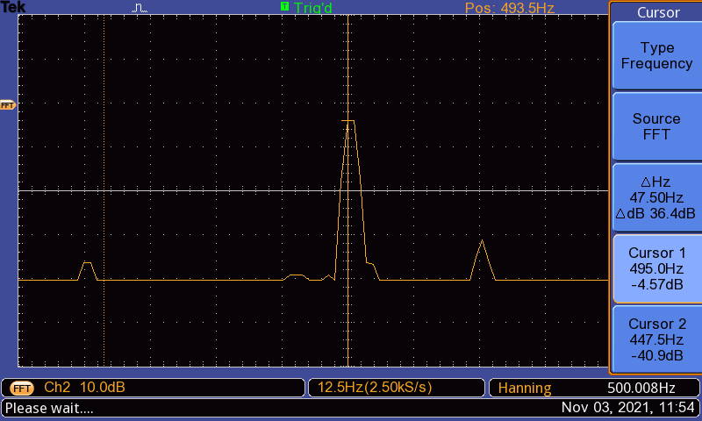

Figure: Spectrum of demodulated signal

We see the following results:

As we can see, the 20 kHz component is not present anymore.

**Evaluation**

**Problem 1: AM Modulated Signals in Time Domain**

Question 1

The modulation index is a ratio of the amplitude of the modulation signal to the amplitude of the carrier signal. As derived in prelab, it can be presented as follows:

Here, Amax is the maximum amplitude of the modulated signal and Amin is the minimum amplitude of the modulated signal.

Question 2

The results of our measurements is as follows:

|  |  |  |
| --- | --- | --- |
| Modulation Index (m) | Amax/V | Amin/V |
| 50% | 3.76 | 1.28 |
| 70% | 4.24 | 0.8 |

At m = 50% = 0.5,

At m = 70% = 0.7,

In both cases, we can see that the calculated values are very close but somewhat lower than the modulation index applied through the signal generator. When we applied a modulation index of 50%, we obtained an experimental value of 49.2%. When we applied a modulation index of 70%, we obtained an experimental value of 68.3%. The error between the values is very low, and are within an acceptable range. It is possible that the error is caused by the signal generator or the resolution of the oscilloscope. There could also be some precision error since we measured the values using the cursors.

Question 3

A modulation index over 100% results in overmodulation. As a result of this, we lose information on the original signal due to distortion of the modulated signal. Consequently, it becomes impossible to reconstruct the original signal from the modulated signal. This occurs because when we try to demodulate an overmodulated signal, part of the envelope is cut off and as a result, we are losing information on the original signal. Therefore, we need to keep m lower than 100%.

**Problem 2: AM Modulated Signals in Frequency Domain**

Question 1

Theoretically, the spectrum of the modulated signal consists of 3 peaks: a peak at the carrier frequency, a peak at carrier frequency shifted to the right by modulating frequency, and a peak at carrier frequency shifted to the left by modulating frequency.

The settings of the signal generator are as follows:

Signal Shape = Sine

Modulation = AM

Carrier frequency = 20 kHz

Carrier amplitude = 10 Vpp

Modulation frequency = 500 Hz

Modulation index = 70%

Therefore, theoretically, carrier frequency should be 20kHz with a modulation frequency of 500 Hz, which should result in a modulated signal with a carrier peak at 20kHz, and sideband peaks at 19.5kHz and 20.5kHz.

Experimentally, however, the carrier peak is found at 19.81kHz, and the sideband peaks are found at 19.30kHz and 20.31kHz. Therefore, the theoretical values don’t exactly match the experimental values, but they are very close. For all three experimental values, the error is about 1%.

From experimental data, we obtain the following magnitudes:

Theoretical values:

As we can see, the magnitudes differ greatly.

Question 2

DSB-SC AM signal is a double sideband suppressed carrier signal. However, our FFT shows a peak at the carrier frequency. Therefore, the function generator is producing a DSB AM signal.

Question 3

Changing the carrier frequency will cause the entire spectrum to shift in the frequency domain. Increasing the carrier frequency will shift the spectrum to the right, while decreasing the carrier frequency will shift the spectrum to the left.

Question 4

The spectrum of the modulated signal consists of 3 peaks: a peak at the carrier frequency, a peak at carrier frequency shifted to the right by modulating frequency, and a peak at carrier frequency shifted to the left by modulating frequency. Therefore, changing the message frequency will change the distance between the peaks on the spectrum. Increasing the message frequency will take the peaks further apart from each other, while decreasing the message frequency will bring the peaks closer together.

Question 5

The measured values are as follows:

The peaks are at the following magnitudes:

Frequency measurements are provided below:

From the data above, it can be deduced that:

The original modulation index is 70%, so there is a 3.77% difference between the theoretical and experimental results, which could be due to precision error while taking measurements with cursor.

**Problem 3: Demodulation of a message signal**

Question 1

From the oscilloscope output, we see that there are some noticeable differences between the outputs of the first order filter and the third order filter. The first order filter does not show any phase change in its output, while the third order filter does. However, the output of the first order output is distorted and noisy, which means some residual effect of the carrier signal has been carried over to the 1st order output. In contrast, the output of the 3rd order filter is much smoother and sharper. Therefore, the 3rd order filter provides a better-quality demodulated signal than the 1st order signal.

Question 2

The results obtained from the experiment are very similar to the results obtained from MATLAB. We can see that there is some distortion in the output of the 1st order filter using MATLAB, which is similar to the results we found for the 1st order filter on the oscilloscope. The MATLAB output for the 1st order is filter is smoother than what we see on the oscilloscope, which could be because they come from an ideal scenario.

Another noticeable similarity is that the MATLAB output from the 3rd order filter is smoother than the output from the 1st order filter. The same can be seen from experimental results.

One noticeable difference between the simulation and the measurements is the phase shift of the output from the 3rd order filter. Even if there is a phase shift in the simulation, it’s not discernible. However, the phase shift noticed in the experimental results is very discernible.

**Conclusion**

The main objective of this lab was to study AM Modulation and Demodulation of a signal. We studied the results of AM modulation and demodulation in frequency domain and time domain. For prelab, we simulated the modulation of a sinusoidal signal on a carrier, and studied the wave in time and frequency domain. This allowed us to obtain an understanding of what to expect in the lab. Then, we built simulations for 1st order and 3rd order low pass filters, and observed the effects of demodulating our modulated signal using those low pass filters.

In lab, we generated the same modulated signal on a signal generator and observed the signal on the oscilloscope. We studied the effects of increasing the modulation index on the modulated signal, and concluded that it shouldn’t be greater than 100%. Then we studied the spectrum of the modulated signal at 70% modulation index. After that, we built a demodulation circuit with 1st order and 3rd order output, and observed the results of passing the modulated signal through it.

For evaluation, we were able to compare our experimental data with our theoretical and simulated results. There were some discernible similarities and differences that could be easily explained by the differences in experimental conditions when compared to the ideal conditions.

By the end of the experimentations, we could reach some valuable conclusions:

1. The spectrum of the modulated signal consists of 3 peaks: a peak at the carrier frequency, a peak at carrier frequency shifted to the right by modulating frequency, and a peak at carrier frequency shifted to the left by modulating frequency.
2. The modulation index should not be increased to a value that is more than 100%.
3. A higher order filter is able provide a better-quality demodulated output of a modulated signal.

These are only some of the important observations that we explored through our experimentations. We encountered some deviations in our experimental data when compared with the theoretical calculations, but these could be explained through the inherent error in equipment such as the resolution of oscilloscope and internal resistance of signal generator, and also through the error in precision when taking measurements with the cursor.

**References**

* Signals and Systems Lab Manual (Uwe Pagel)
* http://www.faculty.jacobs-university.de/upagel/

**Appendix**

**Prelab FM Modulation**

**Problem 1: Frequency Modulator**

**Problem 2: FM signal in the frequency domain**

The script is provided below:

F_c = 40000;

Ac = 2.5;

F_m = 5000;

t_min = 30*10^-3; % minimal signal length

d = [1000, 5000, 10000];

B = d / 5000;

F_s = F_c * 8; % Sampling frequency

F_nyq = F_s/2; % Nyquist frequency

Ts = 1/F_s * (2^nextpow2(t_min * F_s));

t_dom = 0: 1/F_s : Ts - 1/F_s;

for i = 1:length(B)

w_c = 2*pi*F_c ;

w_m = 2*pi*F_m;

A_fm = Ac*cos(w_c*t_dom + B(i)*sin(w_m*t_dom));

L_t = length(t_dom);

FFT_fm = 2*abs(fft(A_fm))/L_t;

FFT_fm = FFT_fm(1:end/2);

f_dom_fm = linspace(0, F_nyq, length(FFT_fm));

figure(i);

log_fm = 20 * log10 (FFT_fm/sqrt(2));

plot (f_dom_fm, log_fm, 'LineWidth', 2);

xlabel('f/Hz'); ylabel('A/dBrms');

ylim ([-40, 10]);

xlim ([10^3, 70*10^3]);

grid on;

end

For , we have the following spectrum:

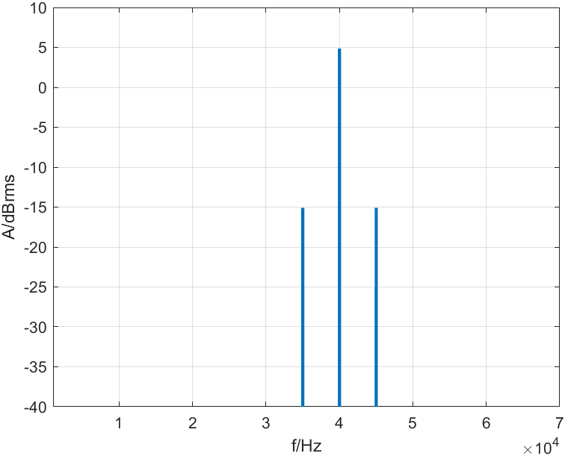

For , we have the following spectrum:

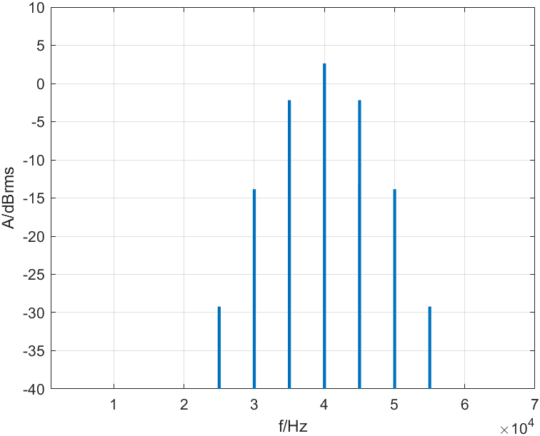

For , we have the following spectrum:

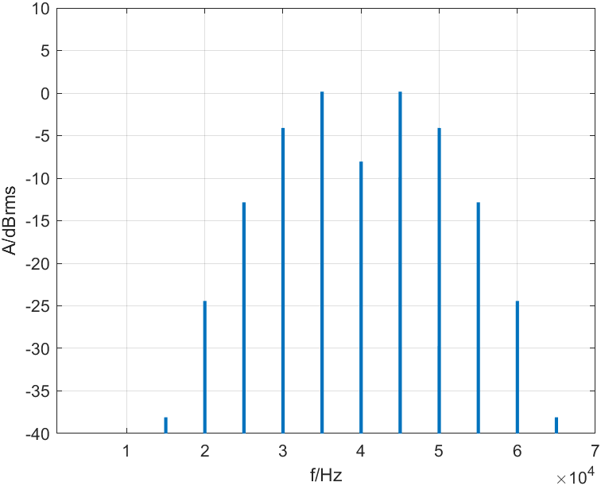

We know that



At :

At :

At :

The peak magnitudes are tabulated below:

|  |  |  |  |  |  |  |  |  |  |  |  |
| --- | --- | --- | --- | --- | --- | --- | --- | --- | --- | --- | --- |
|  | 15 kHz | 20 kHz | 25 kHz | 30 kHz | 35 kHz | Center | 45 kHz | 40 kHz | 55 kHz | 60 kHz | 65 kHz |
| 0.2 | - | - | - | - | -15.095 | 4.681 | -15.095 | - | - | - | - |
| 1 | - | - | -29.223 | -13.845 | -2.181 | 2.624 | -2.181 | 13.845 | -29.223 | - | - |
| 2 | -38.101 | -24.423 | -12.844 | -4.100 | 0.168 | -8.051 | 0.168 | -4.100 | -12.844 | -24.423 | -38.101 |

**Problem 3: Frequency Demodulation**

MATLAB script for the bode diagram is provided below:

R = 100;

C = 10^-6;

L = 10^-1;

s = tf('s');

Z_R = R;

Z_C = 1/(s*C);

Z_L = s*L;

Z_out = ((1/Z_L)+(1/Z_C)+(1/Z_C)+(1/Z_R))^-1;

H = Z_out/(Z_out + Z_R);

bode(H);

The Bode plot is provided below:

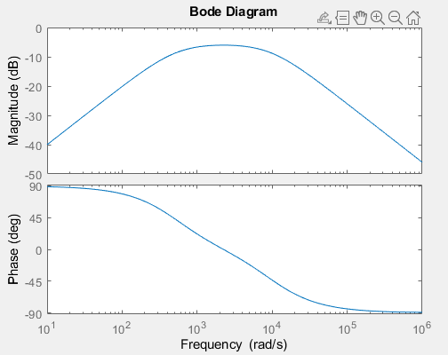

The input circuit is a resonance circuit with bandpass characteristic. It can act as a 2nd order filter with 40 dB/decade slope since it has 2 reactive components. We can use the linear portion of the cutoff region from the high pass part of the circuit, and must make sure damping is minimized. The center of frequency of the FM is placed somewhere on the slope. The output of the filter will look like an AM modulated signal.

The second part of the circuit is an envelope detector. It is a higher order filter and a rectifier, so it is used to recover the message signal from the AM modulated output of the input circuit.